DIRECTIONS TO KERN COUNTY FAIRGROUND
1142 South P Street
Bakersfield, CA 93307
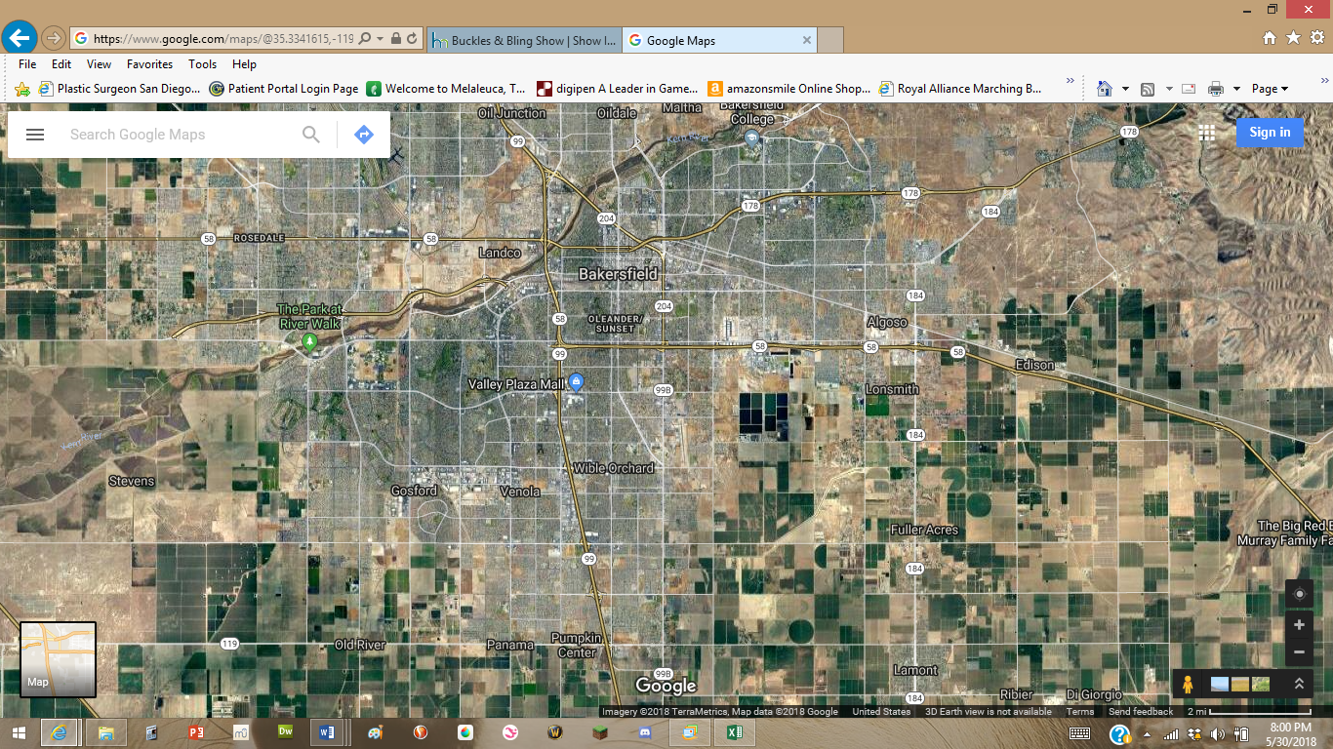
From 99 N
From 58 E
From 99 S

From 58 West – Turn off on Union Ave Exit and turn right on S Union Ave
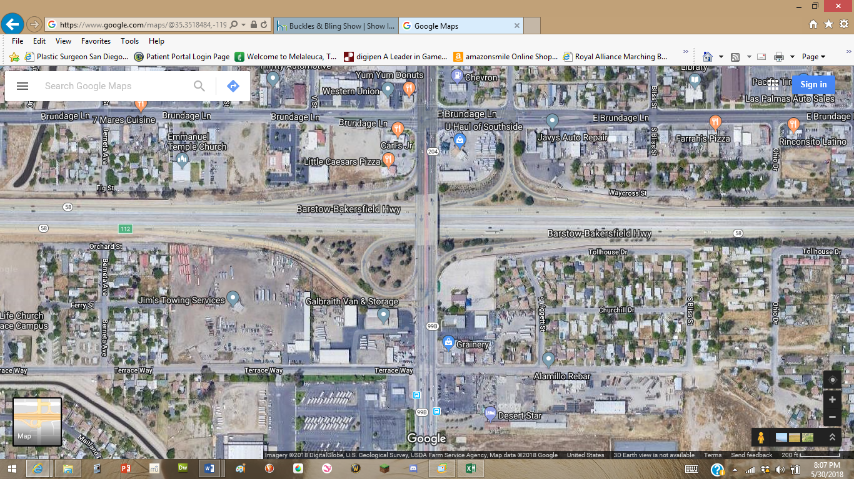
From 58 East – Tun off on Union Ave Exit. Turn left onto E Brundage Ln (1st light) and then turn left onto Union Ave
←58 East

Continue down S Union Avenue (99B). Turn Right on Belle Ter. Turn Left onto S. P Street. Turn Left into the Fairground at Gate 26. Gate code will be provided prior to the show or text Tracy at 760-468-2004 or Sue at 661-754-6251.
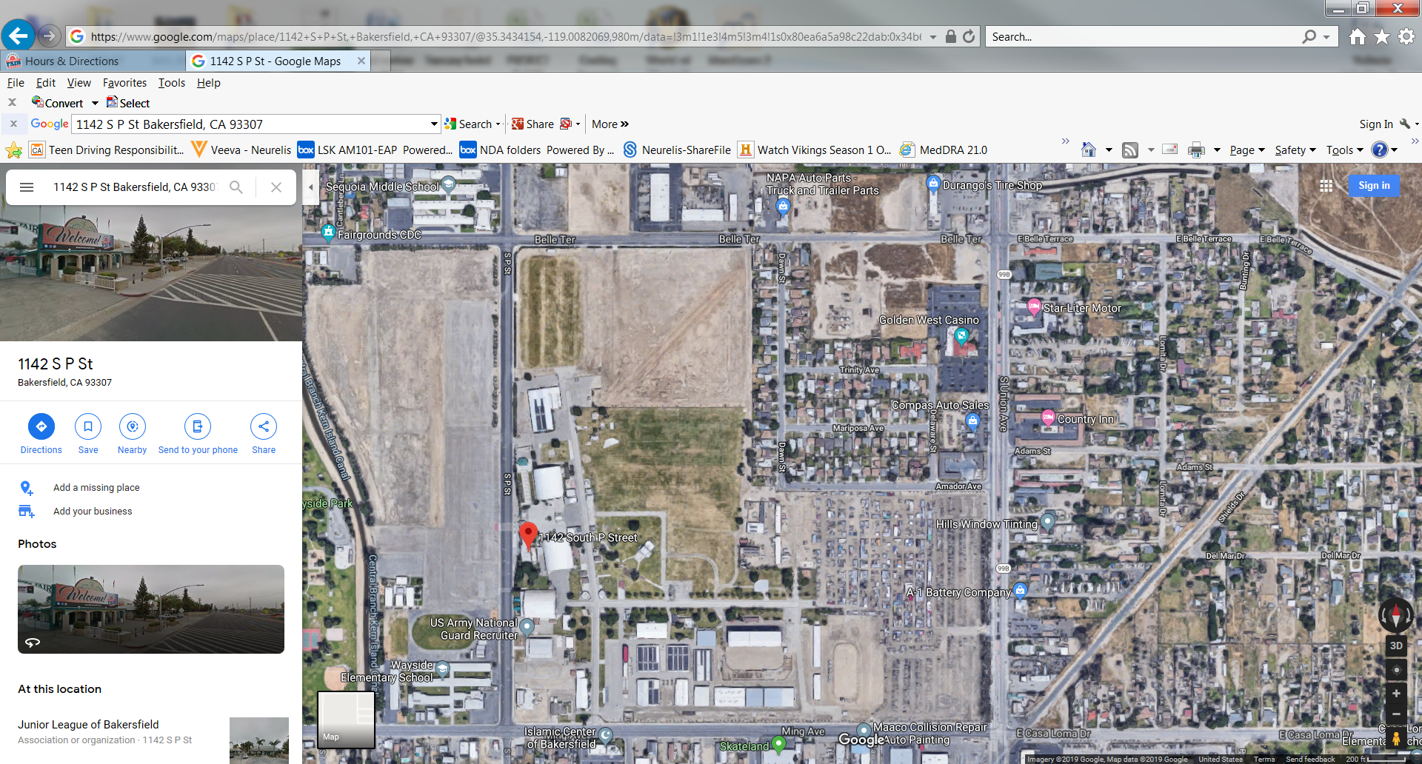
Map to the Camping Area and the Goat Barn
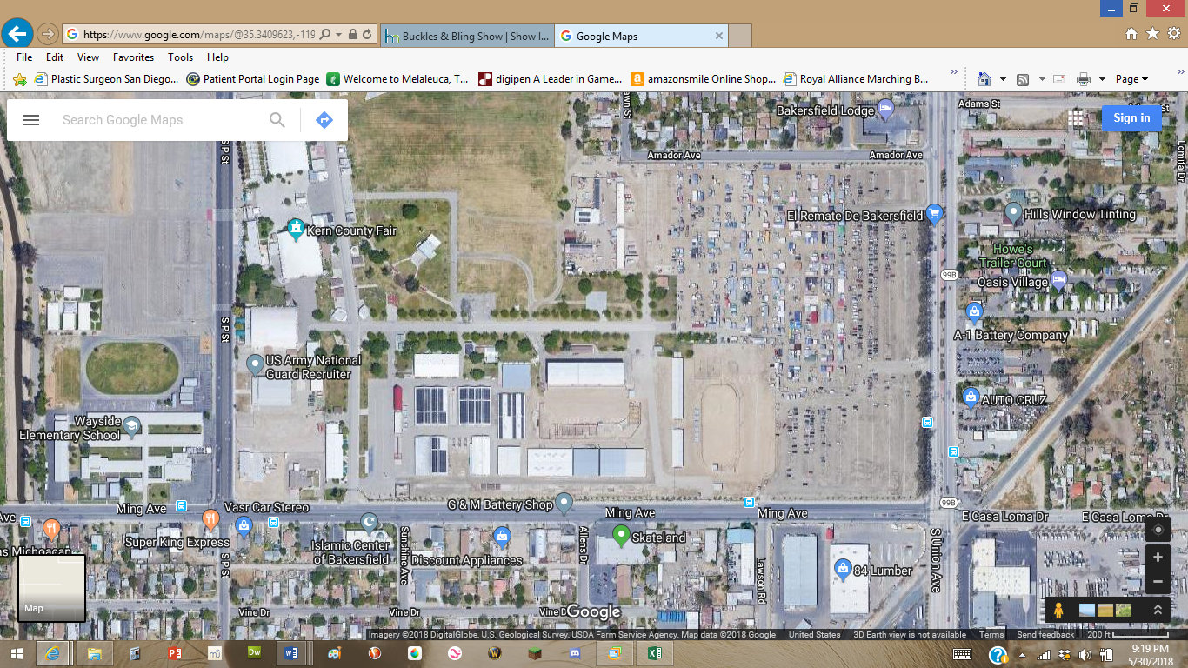
Goat Barn and Arena
Camping Area
Bathrooms

